Quick-ly Aid: An Incident Report Generator System

Project Documentation Submitted to the Faculty of the

School of Computing and Information Technologies

Asia Pacific College

In Partial Fulfillment of the Requirements for

SHS Bootcamp

By

Charles B. Capagngan

Neil Gabriel M. Chavez

Jared Christian Marcos Gatchalian

Paul Matthew P. Llanillo

Cristian R. Saldua

Table of Contents

Executive Summary i

List of Figures ii

Introduction 1

Project Context 1

Statement of the Problem 2

Objectives 3

Significance of the Project 3

Scope and Limitations 4

Review of Related Literature / Systems 6

Technical Background 9

Current System 9

Proposed System 10

Technologies Used 12

Conclusion 14

References 15

Appendices 16

Appendix A: Project Vision 16

Appendix B: Schedule 17

Appendix C: Product Roadmap 18

Appendix D: Users’ Manual 19

Appendix E: Team Meetings 26

26

Appendix F: Source Code 27

Appendix G: Marketing Plan/Study 28

Appendix H: Use Case Full Description 29

**Use Case Name: Access Emergency Services Information** 29

Appendix I: Future Developments 31

Appendix J: Contribution Lists 33

# Executive Summary

Quick - ly Aid, is an innovative emergency response application designed to significantly improve safety in the Philippines. Quick - ly Aid provides a user-friendly platform that connects people with the right respondents and critical information quickly and accurately. The application allows users to select the emergency center that they require, providing personalized quick help. Quick - ly Aid also gives a full directory of emergency numbers in several locations across the country, such as Pasay, Taguig, and Makati, making it easier to find help and reduce response time.

Quick - ly Aid stands out not only for its useful features, but also for its commitment to enhancing public safety. Quick - ly Aid integrates user-centric technology to ensure that everyone can manage situations with trust and comfort, establishing a new standard for emergency response in the Philippines. This innovative approach demonstrates the program's commitment to using technology to enhance the community, which is part of a larger commitment to improving everyone's well-being and security.

# List of Figures

Figure 1: Flow chart of the users for Quick-ly Aid 10

Figure 2: Mockup Design from Figma 11

Figure 3: Gantt Chart Schedule of Developers 17

Figure 4: Product Roadmap 18

Figure 5: Quick - ly Aid Registration Form 19

Figure 6: Quick - ly Aid Verification OTP 19

Figure 7: Quick - ly Aid Data Privacy Act 20

Figure 8: Quick - ly Aid Main Screen 21

Figure 9: Quick - ly Aid Emergency Hotline of Taguig 22

Figure 10: Quick - ly Aid Select City in Emergency Hotlines 22

Figure 11: Quick - ly Aid Emergency Hotline of Makati 22

Figure 12: Quick - ly Aid Emergency Hotline of Pasay 22

Figure 13: Quick - ly Aid Article Page 23

Figure 14: Quick - ly Aid Hospital Around Taguig 24

Figure 15: Hospital City List Page 24

Figure 16: Quick - ly Aid Hospitals Around Pasay 25

Figure 17: Quick - ly Aid Hospitals Around Makati 25

Figure 18: Team Pogi Meeting Number 2 26

Figure 19: Team Pogi Meeting Number 1 26

Figure 20: Team Pogi Meeting with their IBM Mentor 26

# Introduction

The developers of the Quick - ly Aid project have initiated this endeavor to tackle the pressing issues faced by citizens during emergencies. Historically, citizens have struggled with not knowing which emergency hotlines to call, compounded by the problem of prank and incomplete emergency calls, which have been significant challenges for responders. These two critical issues inspired the developers to create this project as a solution.

The primary goal of the Quick - ly Aid project is to address the citizens' lack of knowledge regarding emergency hotlines in their cities and to mitigate the impact of prank calls that responders have been dealing with for a long time. Often, citizens delay contacting emergency responders due to their uncertainty about the appropriate emergency hotline to use for their specific city. This project aims to simplify the process for citizens in need, enabling them to contact emergency hotlines effortlessly, regardless of their location.

The Quick - ly Aid project has several key objectives: to develop a user-friendly application that provides immediate access to the correct emergency hotlines based on the user’s location, to reduce the frequency of prank and incomplete calls that hinder emergency response efforts, to enhance the efficiency and effectiveness of emergency services by ensuring that genuine calls are prioritized, and to increase public awareness and knowledge of emergency contact information. By achieving these aims, the Quick - ly Aid project will significantly improve the response time and reliability of emergency services, contributing to a safer and more informed community.

## Project Context

This aim of this project is to create an easy-to-use emergency response application that lets citizen Quick - ly connect with emergency services in Makati, Pasay, and Taguig, Here in the Philippines and the app's main features include letting users call local emergency hotlines and see the list of hospitals near them with information like addresses, the name of the hospital, and a Google link map and also the app has sub-functionalities that help users to become more prepared by providing articles on what to do in emergency situations and general safety tips. The app aims to speed up response times and make residents and emergency responders safer by making use of these features.

## Statement of the Problem

In case of an emergency, quick help is often essential to ensure safety and reduce harm. However, three main problems often slow down emergency responses.

Firstly, many people do not know the correct emergency hotlines for their city. This lack of information causes delays in getting help, as people might call the wrong number or not know who to contact in a crisis.

Secondly, prank calls to emergency hotlines are a significant issue. These fake calls waste valuable time and resources, making it harder for emergency services to help those in real need. When emergency teams must deal with these prank calls, it takes their attention away from true emergencies.

Lastly, language barriers can hinder effective communication during emergencies. In a diverse city, not all callers may speak the local language fluently, which can lead to misunderstandings and delays in receiving the necessary assistance. Ensuring that emergency services can communicate with all individuals, regardless of language, is crucial for a timely and effective response.

## Objectives

The developer's primary objective is to make emergency assistance available to all and to partner with Makati, Pasay, and Taguig using the new emergency app; the app will be promoted via social media and local partnerships. This project will leverage existing development resources to bring such features to life, keeping user data private and secure. This should be done and completed within the next month so that the launching of the app can be done, and the users oriented. The ultimate objective is to develop and launch an app that would enable residents of Makati, Pasay, and Taguig to easily access emergency help.

The specific objectives that follow from the above objectives are to make user-friendly features so users can find the emergency hotlines now they need to find and reach the correct services easily in a time of crisis. Another specific objective is to assure data privacy and security by enforcing harsh measures to protect user information and keep compliant with privacy laws and best practices. Finally, the app will be actively marketed with a strategy in which the company will involve social media and local partnerships to raise awareness and increase the app's usage among residents. Finally, the developer intends to have development, testing, and integration of the features done within the next month, followed by training sessions both initial and ongoing to educate users on how to operate the application effectively in an emergency.

## Significance of the Project

The application can save lives by enabling timely and expedient access to emergency services to its residents and guests in Makati, Pasay, and Taguig. Occurrences of such a nature whereby response time is cut short by immediate communication between users and the right people during such emergencies have been realized. Another thing is that it offers safety tips which are useful for averting crises. It would also enable emergency response teams to obtain more accurate information, hence leading to more efficient action taken by them. This leads us to an improved coordination as well as quick aid during emergency situations.

## Scope and Limitations

**Scope**

1. Design and Development Tools:

* The app will be designed using Figma for the user interface and experience design.
* Android Studio will be used for developing the app for Android devices.

2. Core Features:

* Emergency Categories:
  + - Fire Department: The application will provide contact information and addresses for fire departments in the specified cities.
    - Hospital: The application will provide contact information and addresses for hospitals in the specified cities.

3. Geographical Coverage:

* Makati: The application will include emergency contact information for fire departments and hospitals within Makati.
* Pasay: The application will include emergency contact information for fire departments and hospitals within Pasay.
* Taguig: The application will include emergency contact information for fire departments and hospitals within Taguig.

4. Database Management:

* The app's data will be stored and managed using Firebase, which will handle user data and emergency contact information.

**Limitations**

1. Geographical Coverage:

* The application is limited to providing emergency contact information for only three cities: Makati, Pasay, and Taguig. It does not cover any other locations beyond these three cities.

2. Emergency Categories:

* The application is restricted to two emergency categories: fire departments and hospitals. It does not include other emergency services such as police departments, ambulance services, or disaster response units.

3. Feature Limitations:

* No Tracker: The application does not include a feature to track the user's location or the real-time status of emergency services. Users will need to manually search for and contact the appropriate emergency service.

By defining these clear boundaries, the development team can focus on delivering a high-quality app within the specified parameters, ensuring that the emergency response application meets the needs of residents in Makati, Pasay, and Taguig effectively.

# Review of Related Literature / Systems

This chapter provides an in-depth overview of several topics including emergency hotlines, emergency calls, and the value of being aware of local hospitals. The understanding and awareness of emergency hotlines in general, issues related to emergency calls—with a special emphasis on hoax calls and the importance of hospital sites for efficient emergency response comprise the three main components of the chapter. To illustrate the current situation and difficulties facing emergency response systems, each part makes use of pertinent research and data.

**Knowledge of Emergency Hotlines**

In a study conducted by Clark et al. (2020), it is mentioned that the percentage of individuals who are aware of the local emergency number varies greatly between nations, and there is some indication that both younger and older individuals are less aware of the emergency numbers at their places. Having an app that provides the knowledge for each emergency hotlines is crucial for the public to reduce panic and for help responders to get on time incase of an emergency.

**Emergency Calls Problems**

In 2019 the governments emergency hotlines in the Philippines received 18.4 million calls and a total of 2.54 million are hoax or prank calls. Only 16,763 calls were non-emergency, and just 37,440 were legitimate. (DILG, 2020). Dealing with prank calls can greatly cost a lot of time especially for those who in need of an emergency. These prank calls cause delays in terms of responders and those who need help.

The government of the Philippines has taken actions to help aid the rising prank or fake calls emergency responders’ deal. On August 22, 2022, House Bill 3851, also known as ‘An Act Penalizing Prank Callers to Emergency Hotlines,” was filed. This act acknowledges the intentionally made fake calls that interrupt the purpose of the emergency hotline, which is to seamlessly receive emergency calls to save lives for those in need at a critical time (House Bill, 2022).

The penalties for those who disobey House Bill 3851 include: arresto menor, which entails a fine of five thousand pesos and a jail sentence of one to thirty (30) days for the first offense; arresto mayor, which entails a jail sentence of one month and one day to six months and a fine of P10,000 for the second offense; and arresto correccional, which entails a jail sentence of six months and one day to six years and a fine of P20,000 for the third and subsequent offenses (House Bill, 2022).

**Knowing Nearby Hospitals**

Knowing the locations of hospitals is essential for emergency preparedness. In cases of natural disasters, accidents, or disease outbreaks, hospitals need to be accessible to manage patient surges and provide critical care. Well-prepared hospitals also coordinate with public health systems to enhance response capabilities during such events. (Kaple, 2020). Some people don’t know where the nearest places for Hospitals are which causes panic, having an app that has a built in Hospital location can help an individual in times of an emergency for it is accessible and can help navigate easily.

Living close to health facilities offers numerous advantages. You can easily achieve peace of mind knowing medical help is readily available, which reduces anxiety and stress. Better mental health leads to enhanced physical health as well (Admin, 2021). The key is to take advantage of the available resources. When choosing a home, look for comprehensive infrastructure that includes public transport, commercial and retail facilities, and healthcare services (Admin, 2021).

**Importance of emergency application**

The benefits of the emergency app are numerous, and its importance is undeniable. An emergency response application's accessibility is one of its primary advantages. An emergency app may be accessed anywhere, at any time, and is often not restricted to places. They can therefore save a significant number of lives by enabling individuals to get emergency assistance wherever (Farah, 2023).

# Technical Background

It is created using simple tools, including design and development as well as reliable test equipment. The team is made up of programmers, designers and testers who collaborate to make sure that the application works properly. This is done through a good internet connection which enables emergency contact details to be updated at the same time. In this respect, it ensures an app that users can rely on to locate fast enough any necessary emergency service.

## Current System

Currently, there is no system established to enable rapid access to emergency hotlines and hospital locations based on the user's city in our application. During an emergency, users must manually look for contact information and locations, which can be time-consuming and distressing. Basic telecommunications are the major technology used for calling emergency numbers, but there is no integrated platform that combines real-time location services with emergency contact information.

**Technologies Used**

**Hardware:** The current system largely uses users' personal mobile devices to access emergency contacts. There is no specialist hardware for this task.  
  
**Software:** Users often find emergency contact information through default phone applications or online searches. There are no dedicated programs or linked systems to help expedite this procedure.  
  
**Network:** The current approach is a bit dependent on mobile network connectivity to navigate other features. Users must be connected to the internet in order to look for the hospital locations. Users may struggle to acquire important information quickly if they do not have a stable internet connection.

## Proposed System

The developer puts forward Quick-ly Aid, covering a holistic span of emergency assistance through an application that will make access to emergency services and healthcare facilities far more accessible. This would work on a combination of software and user-centric design and network technologies to smoothly implement and get the system up and running. This application would provide location-based services in real-time so that the user can effectively search for the nearest hospitals and other emergency contact centers without hassle and wasting time.

Figure : Flow chart of the users for Quick-ly Aid

The application development will be done in such a way that the user can actively view and monitor their location if they are in trouble and cannot seek help. The back-end system will handle the data flow between the mobile application and the database, which will be responsible for the data processing, analytics, and user authentication. Firebase is the DBMS through which secure user data storage can be conducted. It will provide real-time database services with robust cloud storage.

Figure : Mockup Design from Figma

It is such that the design and development will be put into place carefully from UI/UX in Figma to the development of the mobile application in Android Studio and, finally, integration in Firebase for backend processing and functionality. The User Interface (UI) is developed on Figma such that it is aesthetic and user-friendly. This would give a high-quality User Experience on the varied platforms configured under the same User Experience design. The app is currently under development for Android only and is using Android Studio.

The developer will create, develop, and operationalize the system such that from inception, development, and actualization, it is fully accommodated. At the same time, there will be technical support staff if users encounter trouble in troubleshooting the application and managing the infrastructure of the database. Using Wi-Fi and cellular networks will ensure that connectivity is in real-time, daylong, for updates and communication. The application does not need Wi-Fi, but some features that it has—such as the list of the places of the hospitals and access to the articles—will require a connection to the internet to work.

## Technologies Used

**Hardware:**

**Mobile Devices:** Users will access the app through Android smartphones. These devices must have GPS capabilities to enable real-time location tracking.

**Servers:** Cloud servers will host the backend services and the Firebase database to handle data processing, storage, and retrieval efficiently.

**Software:**

**Android Studio:** The primary Integrated Development Environment (IDE) for developing the Android application.

**Firebase:** This will serve as the backend-as-a-service (BaaS), providing real-time database services, authentication, and cloud storage.

**Figma and Canva:** Used for UI/UX design to ensure the application is user-friendly and visually appealing.

**Peopleware:**

**Development Team:** Comprising software developers, UI/UX designers, and project managers who will collaborate to develop, test, and deploy the application.

**Technical Support Staff:** Responsible for providing user support, troubleshooting issues, and maintaining the backend infrastructure.

**Network:**

**Wi-Fi and Cellular Networks:** The application will use Wi-Fi and cellular networks for real-time updating data and communication. While it will require an internet connection for some of its functionality, particularly in the viewing of all news articles and lists of hospitals, it will not need one for the data saved offline or basic, noncritical information for the emergency contact numbers.

All these technologies combined will offer a very effective and reliable application of emergency assistance which will help greatly in enhancing the safety and health of the user. Quick access to emergency services, effective communication, and improved emergency response is what the developed system will provide to its user.

# Conclusion

The Quick-ly Aid application has made significant progress towards providing a comprehensive emergency response solution for the Makati, Pasay, and Taguig metropolitan areas. We have developed a mobile application with robust features aimed at streamlining emergency responses while ensuring user data privacy and security through strong encryption and access control.

Our app leverages real-time location services to provide accurate emergency contact information and nearby hospital locations based on the user's city. Additionally, we have integrated Firebase for real-time database services, data analytics, and user authentication. The UI/UX design was crafted using Canva to ensure a user-friendly interface.

To provide a smooth and user-friendly experience, we will be focusing on finishing the mobile application on Android Studio going ahead. This entails putting in place a user training program, providing technical assistance for a smooth adoption process, conducting extensive system testing to ensure dependability and performance, and improving cellular and Wi-Fi network setups for constant connectivity.

By offering a workable, dependable, and user-friendly solution, this project seeks to improve consumers' emergency response experiences. With the completion of these last procedures, we anticipate a successful launch that will establish Quick-ly Aid as a vital resource for community disaster response and preparation.

# References

Admin. (2021, March 15). Benefits in living close to hospital. Life Medical Clinic. <https://lifemedicalclinic.com.au/benefits-of-living-near-a-hospital/>

Clark, M. J., Enraght-Mooney, E., Balanda, K. P., Lynch, M., Tighe, T., & FritzGerald, G. (2002, April 1). Knowledge of the national emergency telephone number and prevalence and characteristics of those trained in CPR in Queensland: Baseline information for targeted training interventions. ScienceDirect. <https://www.sciencedirect.com/science/article/pii/S0300957201004865>

DILG. (2020, March 4). DILG: Gov’t’s 911 hotline gets 2.54 million prank calls in 2019. Inquirer.net. <https://newsinfo.inquirer.net/1236748/dilg-govts-911-hotline-gets-2-54-million-prank-calls-in-2019>

Farah. (2023, August 28). Emergency response application: What you need to know. Nandbox Native App Builder. <https://nandbox.com/emergency-response-application-what-you-need-to-know/>

House Bill. (2022, September 1). House bill penalizes prank callers to emergency hotlines with jail terms, fines. Manila Bulletin. <https://mb.com.ph/2022/09/01/house-bill-penalizes-prank-callers-to-emergency-hotlines-with-jail-terms-fines/>

Kaple, T. (2020, May 26). Hospital Emergency Preparedness: An online guide for healthcare professionals. EduMed. <https://www.edumed.org/resources/hospital-emergency-preparedness/>

# Appendices

## Appendix A: Project Vision

In a disaster, Quickly Aid is an application that ensures quick and efficient communication with emergency services. It will serve residents, crisis respondents, and staff inside the purviews of Makati, Pasay, and Taguig of the Philippines by consolidating a dropdown highlight for simplicity of correspondence with the pertinent specialists in this way fundamentally diminishing reaction time. It will also include information about where the closest hospitals are and other important safety measures that a community this prepared and well-informed should have. The high-tech equipment will be used here to make the area a safer and better place to live. As a result, people living in such cities will have more money and be happier. The essentials will also be taken into consideration to support the project concept and product. This may consist of user requirements, technical specifications, functional and nonfunctional requirements, and a comprehensive plan for their implementation. This will be a comprehensive strategy that will make it possible to successfully see the project through to completion and ensure that it meets the project objectives' requirements.

## Appendix B: Schedule

Figure : Gantt Chart Schedule of Developers

## Several yellow post-it notes Description automatically generatedAppendix C: Product Roadmap

Figure : Product Roadmap

## Appendix D: Users’ Manual

This is what the user will see when they run the application with their new username. They must Register their Personal Information First before they can use the application.

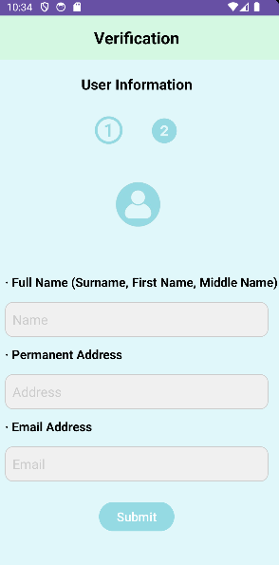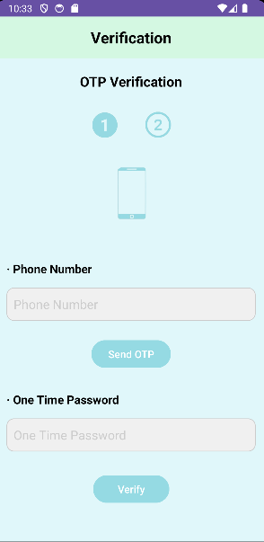

Figure : Quick - ly Aid Registration Form

Figure : Quick - ly Aid Verification OTP

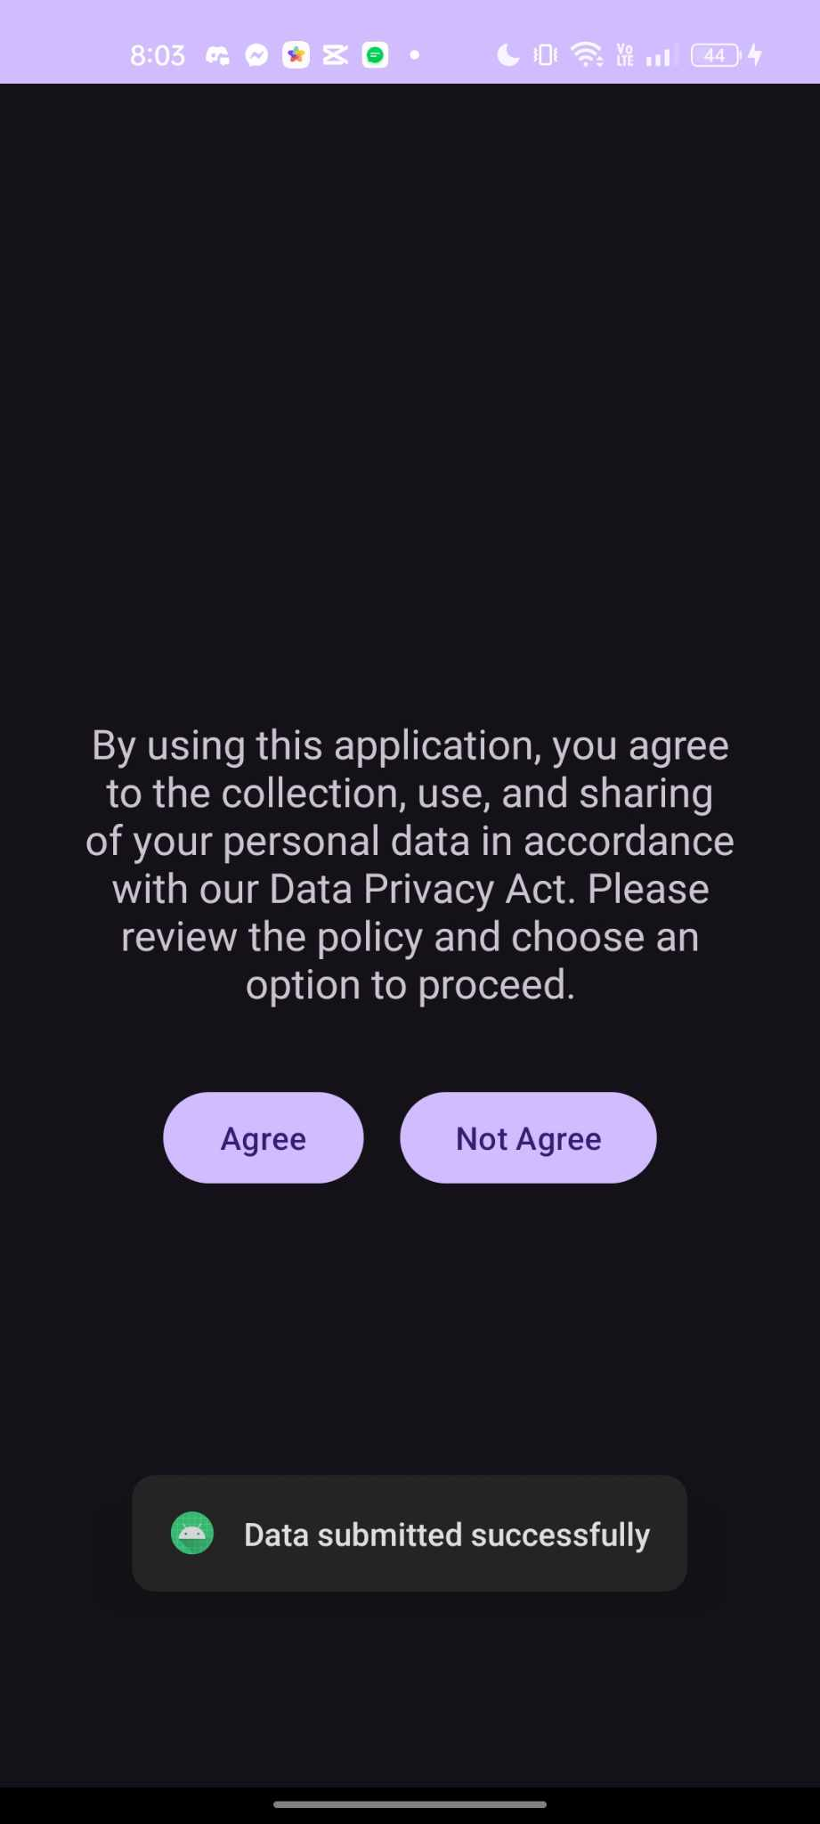

Figure : Quick - ly Aid Data Privacy Act

The data privacy policy will be visible to users when they register their personal information. Because it prevents personal information from being misused and ensures that information is treated responsibly, data privacy is important.

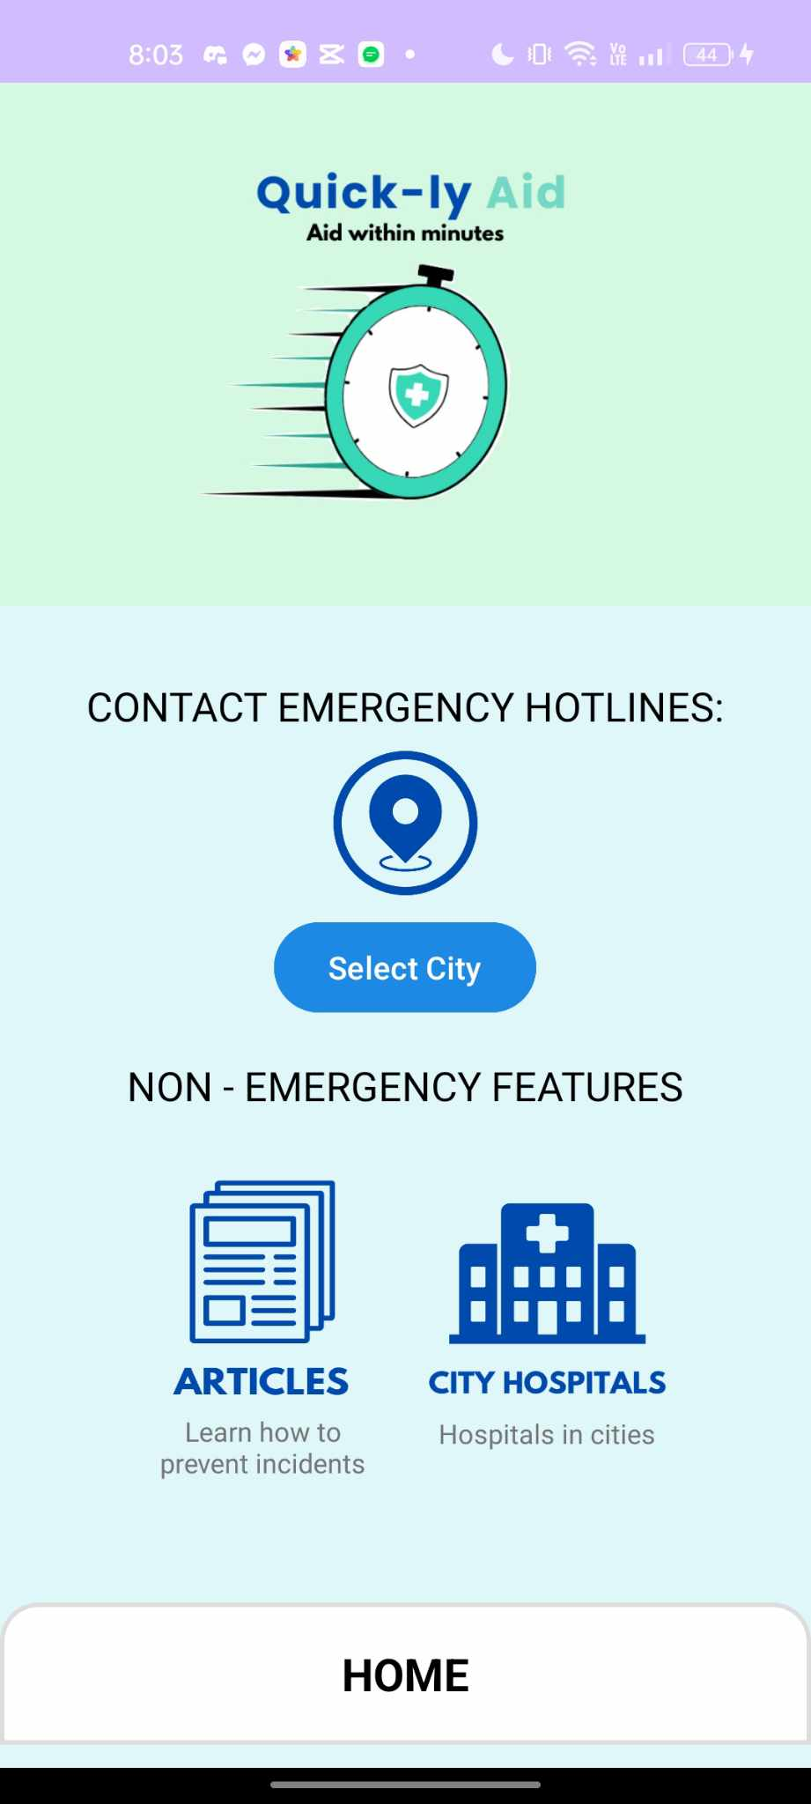

Figure : Quick - ly Aid Main Screen

The user will be directed to our home screen, which displays all of our services, including the ability to contact emergency hotlines, browse articles, and view a list of City Hospital Places, once they have consented to the data privacy act.

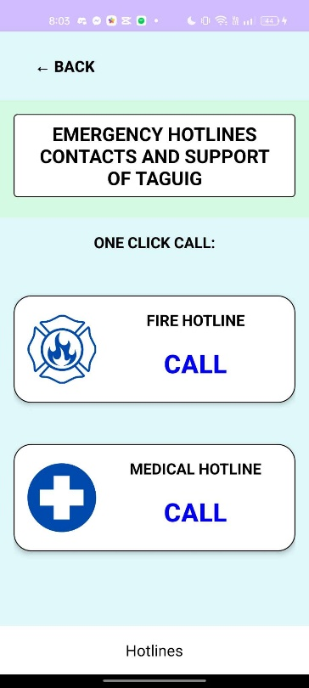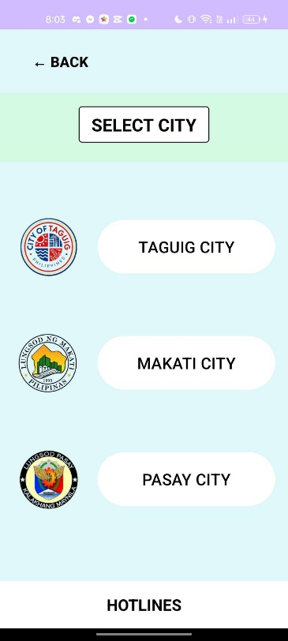

Figure : Quick - ly Aid Emergency Hotline of Taguig

Figure : Quick - ly Aid Select City in Emergency Hotlines

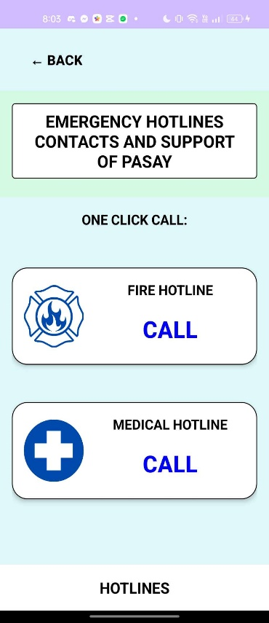

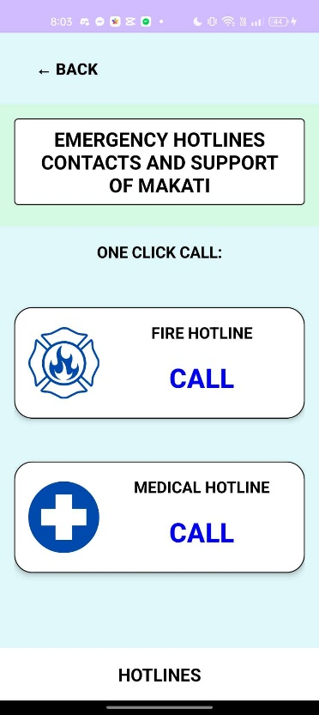

Figure : Quick - ly Aid Emergency Hotline of Makati

Figure : Quick - ly Aid Emergency Hotline of Pasay

When the user clicks on the Contact Emergency Hotline and chooses "Select City," three cities are displayed for them to pick from: Pasay, Makati, and Taguig. They will be directed to a different interface after choosing a city where they can decide between a fire and a medical emergency.

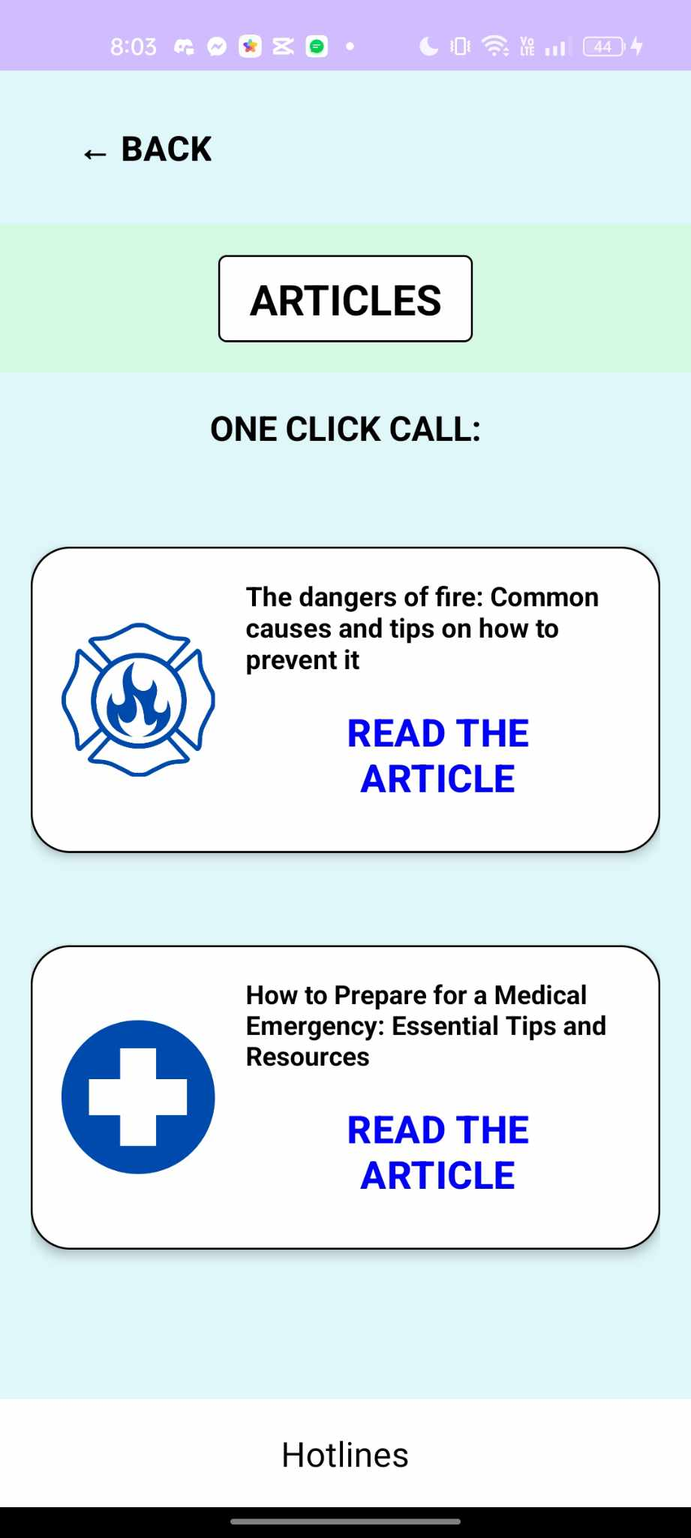

Figure : Quick - ly Aid Article Page

When a user selects the "Article" link from the Main Page UI, a page with useful guidance and precautions on a range of emergency problems will be displayed. In order to assist the users’, stay safe and act appropriately in the event of an emergency, this feature provides helpful advice on addressing fire emergencies, medical emergencies, and many more.

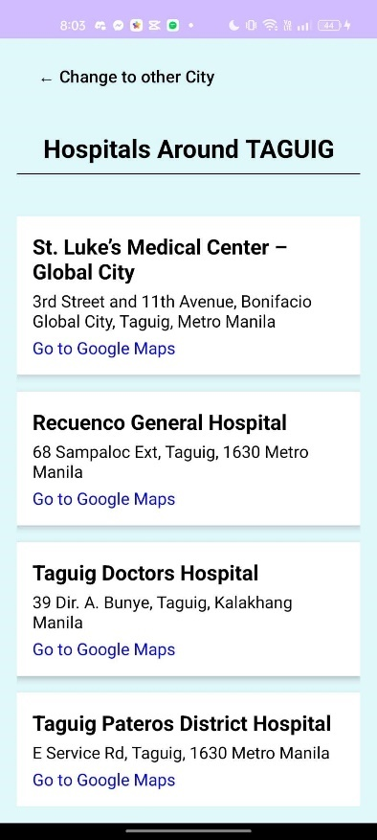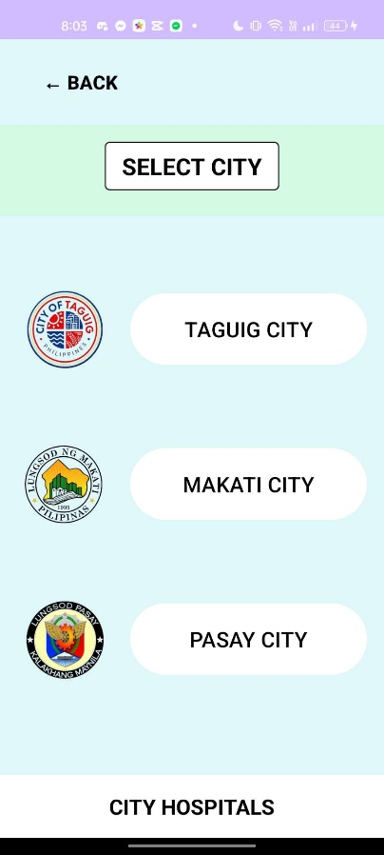

Figure : Quick - ly Aid Hospital Around Taguig

Figure : Hospital City List Page

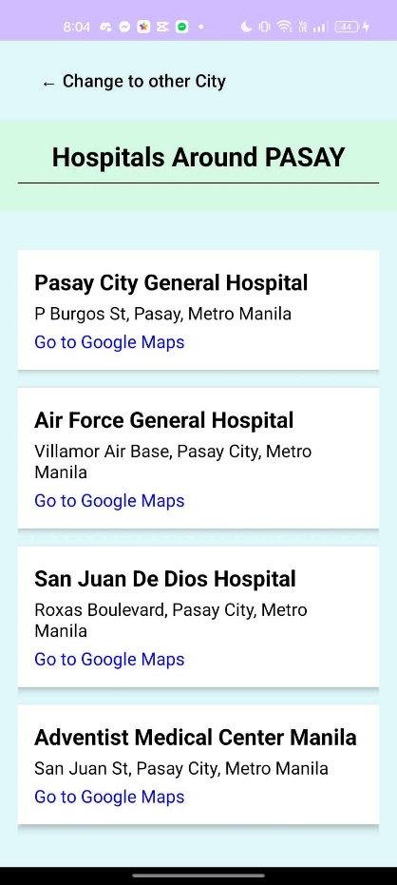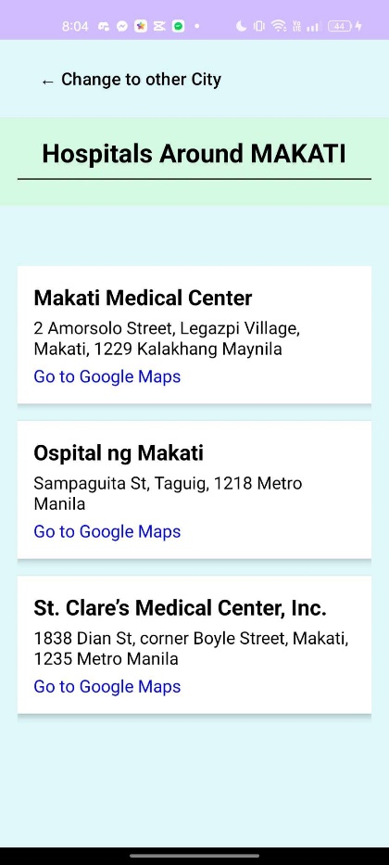

Figure : Quick - ly Aid Hospitals Around Pasay

Figure : Quick - ly Aid Hospitals Around Makati

When the user clicks on "CITY HOSPITALS," they are directed to our Select City User Interface, where they can select a city to browse a list of hospitals. Pasay, Makati, and Taguig are among the available cities. When the user selects a hospital in their target city, they will be sent to Google Maps, which will provide directions to the chosen hospital.

## Appendix E: Team Meetings

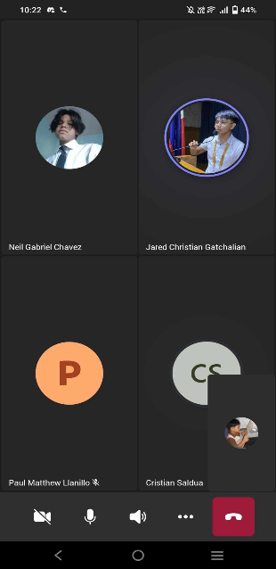

Figure : Team Pogi Meeting Number 2

Figure : Team Pogi Meeting Number 1

Figure : Team Pogi Meeting with their IBM Mentor

## Appendix F: Source Code

(

*Screenshot and link of GitHub repository.*

)

## Appendix G: Marketing Plan/Study

Quick-ly Aid is a mobile application created to give instant access to emergency hotlines and hospital locations based on your city. It is meant for those who need quick help in a crisis, health providers who want to improve patient care as well as local government units focused on public safety. This marketing plan describes how we will promote this app so that people download it and use it often. The product strategy highlights feature such as user-friendliness, real-time location services and complete contact lists for different kinds of emergencies. For everybody to be able to get it easily, Quick-ly Aid can be downloaded for free from anywhere. Some of its major selling points include being able to connect with essential emergency contacts immediately wherever one may be and showing nearby hospitals within the same area where someone is located.

Promotion will mainly use online platforms like social media platforms e.g., Facebook or Twitter among others and email marketing system too. Several organizations' official pages should introduce them regularly while engaging contents which consist of tips user's testimonials or feature highlights must be posted frequently so that people don't forget about them easily after they are launched. Before they come out officially there must be some pre-launch activities carried out like making promotional materials plus creating a tutorial video showing how it works. This should be accompanied with announcements via social media and email where the tutorial is shared to encourage more downloads.

Post-launch,

regular updates and user tips will be maintained through ongoing social media promotion. The app will also be demonstrated at health fairs, tech expos, and local community events to reach broader audiences. Media coverage and credibility will be gained by using press releases as well as articles in both health and tech magazines among others. Furthermore, there will be implementation of referral bonuses along with limited-time free premium features to enhance user engagement & retention levels. The relevancy of providing emergency assistance can only be upheld if Quick-ly Aid is continually updated based on feedback from its users. Therefore, this marketing strategy should make sure that the application becomes a must-have for safety and health during emergencies once fully executed.

## Appendix H: Use Case Full Description

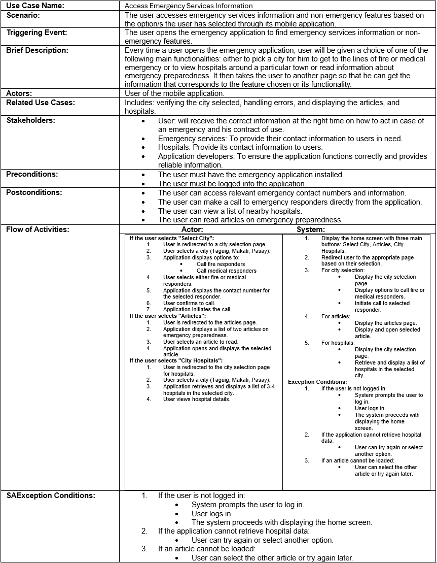

## Appendix I: Future Developments

1. **GPS locator**
   * This feature will let the application provide a real-time GPS tracker to determine the user's current location.
2. **City hotline update based on location**
   * The application will update the emergency hotline number wherever the user is.
3. **Responders end UI and Functionality**
   * The responders will have their own application and see the information of the caller.
4. **Messaging Report**
   * The users will be able to communicate with responders through messages.
5. **Track nearby hospitals**
   * The user will be able to see the hospitals near their location.
6. **Better OTP**
   * The current OTP feature lacks security and will be improved to a randomized number for each user.
7. **Cover more ciities**
   * Add more cities the app can respond to.
8. **More emergency categories**
   * Add more emergency categories for users to choose from.
9. **Offline Feature**
   * Make offline features for the application.

# Appendix J: Contribution Lists

**Charles B. Capagngan**

* Documentation
* Coding
* UI Design for Verification

**Neil Gabriel M. Chavez**

* Documentation
* Coding
* UI Design for Main Page

**Jared Christian Marcos Gatchalian**

* Documentation
* Coding
* UI Design for Main Page

**Paul Matthew P. Llanillo**

* Documentation
* Coding

**Cristian R. Saldua**

* Documentation
* Coding
* UI Design for Main Page

# Appendix J: Design Thinking

Activity 1 of Design Thinking (Alarm Clock)

Activity 2 of Design Thinking (Problem Rundown)

Activity 3 of Design Thinking (Empathy Map)

Activity 4 of Design Thinking (EBR and Hills)

Activity 5 of Design Thinking (Prototype)